**Cancellation Of Records**

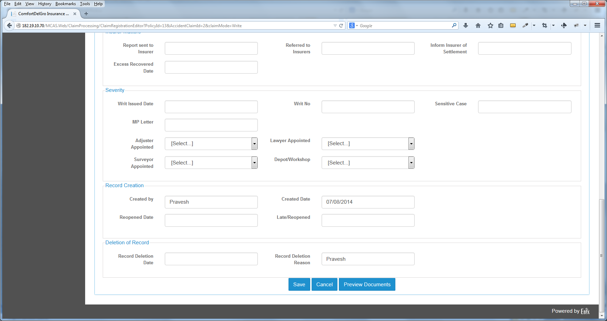

1. Change the Cancel Label (for all Modules) To “Reset”. When this is clicked, the System will clear all the input entries.

2. Change the Deletion of Record to “Cancellation of Record”

3. Change the Record Deletion Date Label to “Record Cancellation Date” and Record Deletion Reason Label to “ Record Cancellation Reason” and the field to be multitext box.

4. System needs to detect that when there’s entries in the Record Cancellation Date, the Record Cancellation Reason must be filled in and when User clicks on Save – there will be a prompt message that says “Are You Sure You Want To Cancel This Claim?” and with Yes and Cancel Buttons. If User clicks Yes, System will cancel the claim and update Claim Status as Cancelled.

**Add New LOG**

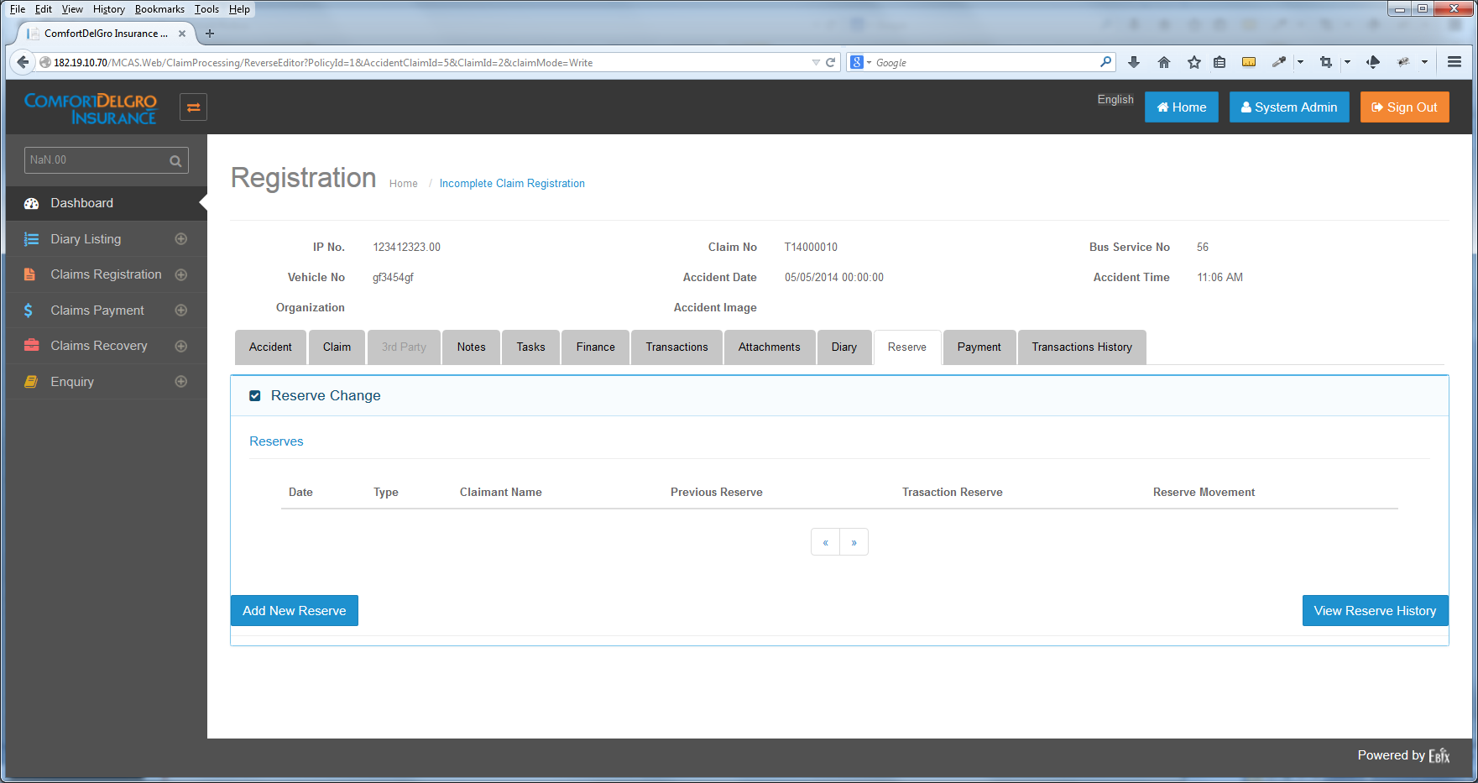

Add New LOG

1. Change the Claimant Name Label to “Claimant Name / Hospital Name”

2. Include A New Type “LOG”

3. Include A “Add New LOG” Button next to the Add New Reserve

4. Section will still look like this:

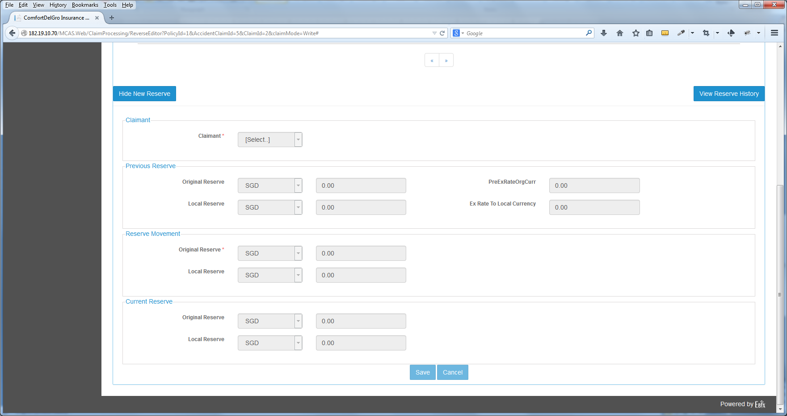

5. Include A “Hide New LOG” Button.

6. Change both Claimant Labels To “Hospital”

7. Include Dropdown Menu to display list of Hospitals. We may need to maintain database for Hospitals (because fields related to hospitals will be mapped to Documents). May need to include a “Add New Hospital” Field beside the Hospital Label if CDGI confirms that we need to maintain.

8. System is to display all LOG Entries under View Reserve History as well.

**Integrate Finance Tab Into Payment Tab**

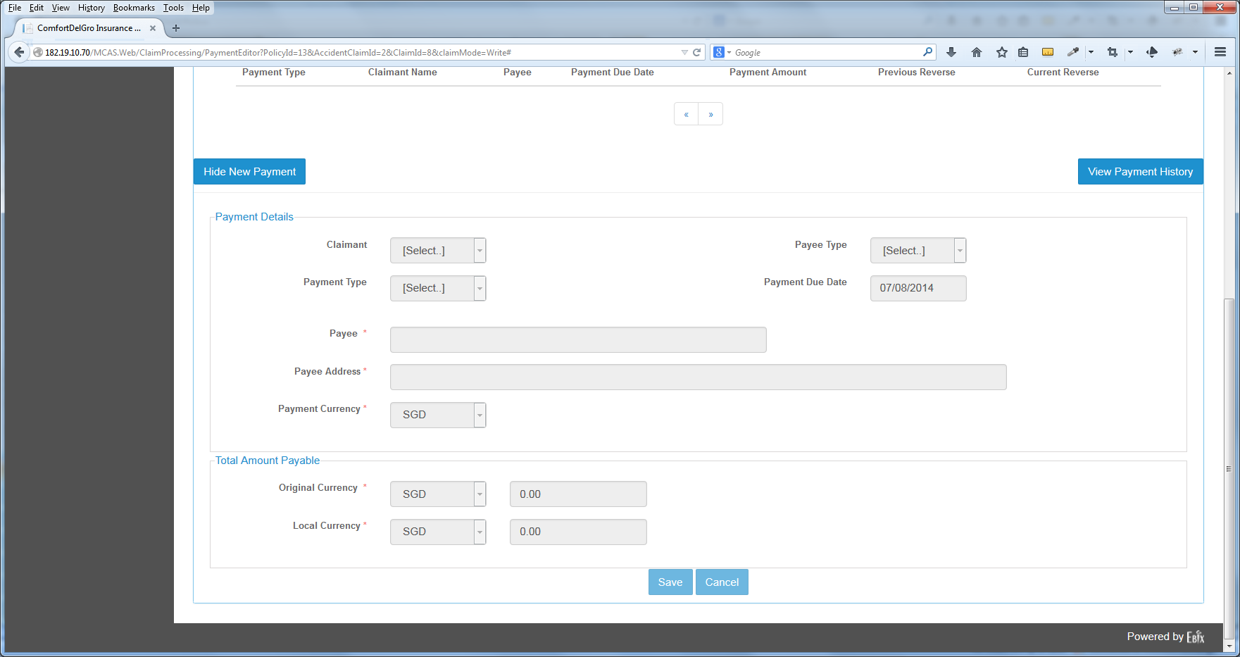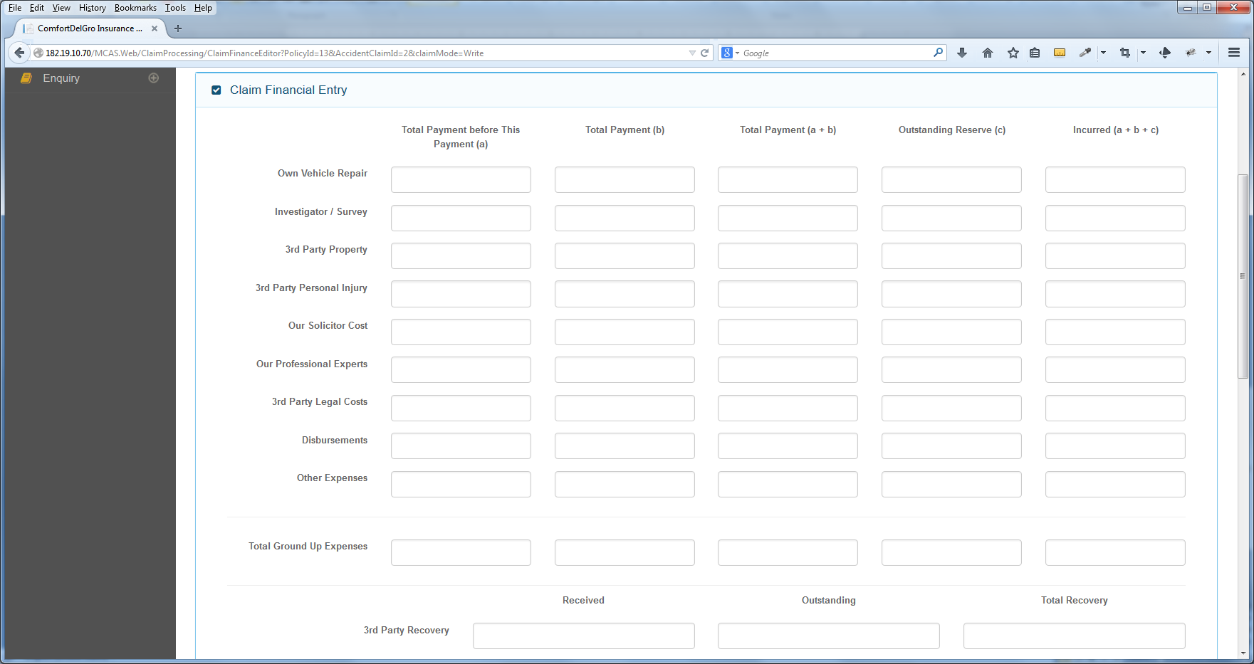

View Payment Breakdown

Add Payment Breakdown

This Value will be populated to one of the fields and will balance out with the breakdowns

1. To add a “Add Payment Breakdown” Button

2. System will populate the value from Local Currency based on the Payment Type to one of the fields in the Finance Tab.

3. System needs to make sure the breakdown entries equal to the Local Currency Value before allowing the User to save.

4. To have a “View Payment Breakdown” Button to allow User to see what have been created for a Payment Entry.

**Alert Indicator**

1. System is to keep track of Accident Reserve and provide an Alert Indicator Message when the Reserve amount is above $15,000.01.

2. System will default Claim Status To “C”

**Claims Documents Printed**

System is to have a function to export out whole listings as Excel as well as to delete any entries